Page 1

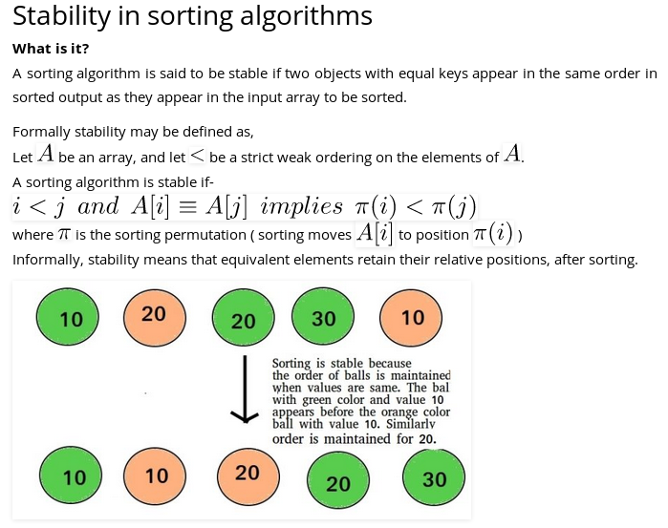
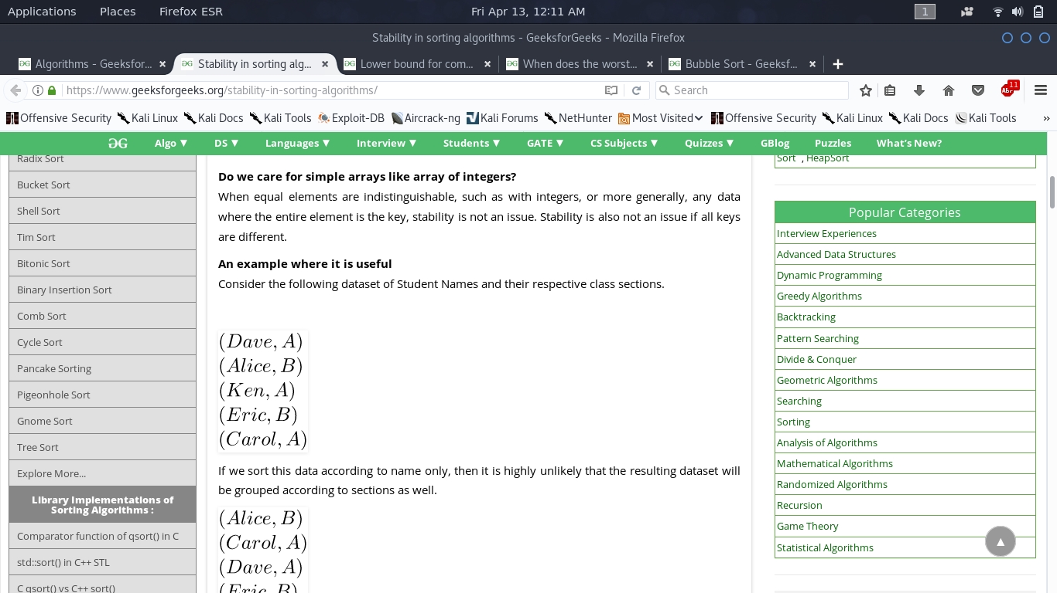
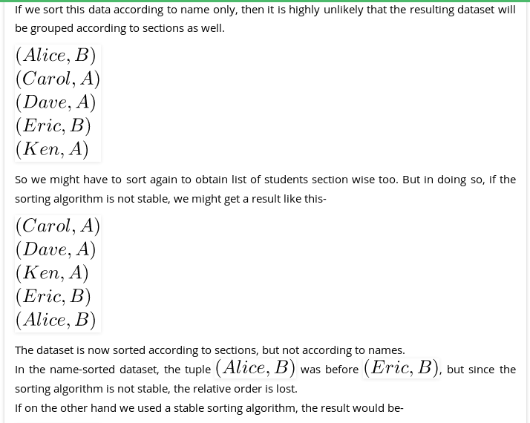

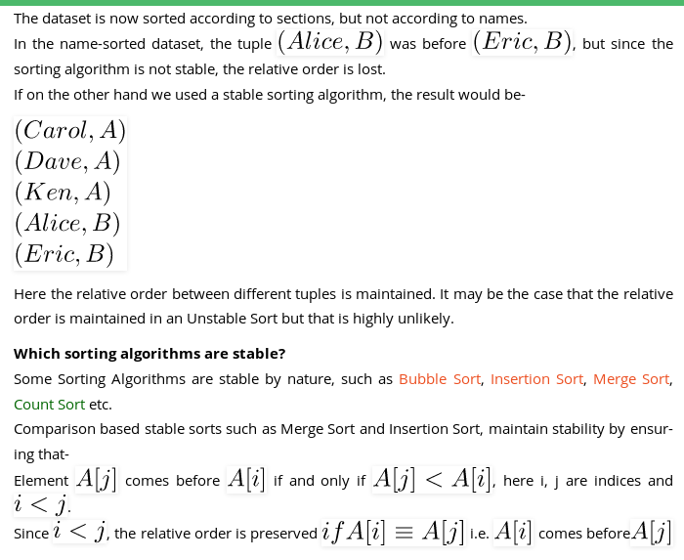

1

When does the worst case of Quicksort occur?
The answer depends on strategy for choosing pivot. In early versions of Quick Sort where leftmost (or rightmost) element is chosen as pivot, the worst occurs in following cases.
1) Array is already sorted in same order.
2) Array is already sorted in reverse order.
3) All elements are same (special case of case 1 and 2)
Since these cases are very common use cases, the problem was easily solved by choosing either a random index for the pivot, choosing the middle index of the partition or (especially for longer partitions) choosing the median of the first, middle and last element of the partition for the pivot. With these modifications, the worst case of Quick sort has less chances to occur, but worst case can still occur if the input array is such that the maximum (or minimum) element is always chosen as pivot.

3Lower bound for comparison based sorting algorithms
The problem of sorting can be viewed as following.
Input: A sequence of n numbers <a1, a2, . . . , an>.
Output: A permutation (reordering) <a‘1, a‘2, . . . , a‘n> of the input sequence such that a‘1 <= a‘2 ….. <= a‘n.
A sorting algorithm is comparison based if it uses comparison operators to find the order between two numbers. Comparison sorts can be viewed abstractly in terms of decision trees. A decision tree is a full binary tree that represents the comparisons between elements that are performed by a particular sorting algorithm operating on an input of a given size. The execution of the sorting algorithm corresponds to tracing a path from the root of the decision tree to a leaf. At each internal node, a comparison ai <= aj is made. The left subtree then dictates subsequent comparisons for ai <= aj, and the right subtree dictates subsequent comparisons for ai > aj. When we come to a leaf, the sorting algorithm has established the ordering. So we can say following about the decison tree.
1) Each of the n! permutations on n elements must appear as one of the leaves of the decision tree for the sorting algorithm to sort properly.
2) Let x be the maximum number of comparisons in a sorting algorithm. The maximum height of the decison tree would be x. A tree with maximum height x has at most 2^x leaves.

After combining the above two facts, we get following relation.

n! <= 2^x

Taking Log on both sides.
log2(n!) <= x

Since log2(n!) = Θ(nLogn), we can say
x = Ω(nLog2n)
Therefore, any comparison based sorting algorithm must make at least nLog2n comparisons to sort the input array, and Heapsort and merge sort are asymptotically optimal comparison sorts.
References:
Introduction to Algorithms, by Thomas H. Cormen, Charles E. Leiserson, Ronald L. Rivest and Clifford Stein
3

Which sorting algorithm makes minimum number of memory writes?
Minimizing the number of writes is useful when making writes to some huge data set is very expensive, such as with EEPROMs or Flash memory, where each write reduces the lifespan of the memory.
Among the sorting algorithms that we generally study in our data structure and algorithm courses, Selection Sort makes least number of writes (it makes O(n) swaps). But, Cycle Sort almost always makes less number of writes compared to Selection Sort. In Cycle Sort, each value is either written zero times, if it’s already in its correct position, or written one time to its correct position. This matches the minimal number of overwrites required for a completed in-place sort.
4

Sort a nearly sorted (or K sorted) array
Given an array of n elements, where each element is at most k away from its target position, devise an algorithm that sorts in O(n log k) time.
For example, let us consider k is 2, an element at index 7 in the sorted array, can be at indexes 5, 6, 7, 8, 9 in the given array.

Recommended: Please solve it on “PRACTICE ” first, before moving on to the solution.

We can use Insertion Sort to sort the elements efficiently. Following is the C code for standard Insertion Sort.
/* Function to sort an array using insertion sort*/
void insertionSort(int A[], int size)
{
int i, key, j;
for (i = 1; i < size; i++)
{
key = A[i];
j = i-1;

/* Move elements of A[0..i-1], that are greater than key, to one
position ahead of their current position.
This loop will run at most k times */
while (j >= 0 && A[j] > key)
{
A[j+1] = A[j];
j = j-1;
}
A[j+1] = key;
}
}
The inner loop will run at most k times. To move every element to its correct place, at most k elements need to be moved. So overall complexity will be O(nk)
We can sort such arrays more efficiently with the help of Heap data structure. Following is the detailed process that uses Heap.
1) Create a Min Heap of size k+1 with first k+1 elements. This will take O(k) time (See this GFact)
2) One by one remove min element from heap, put it in result array, and add a new element to heap from remaining elements.
Removing an element and adding a new element to min heap will take Logk time. So overall complexity will be O(k) + O((n-k)*logK)
5

Iterative Quick Sort
The above implementation can be optimized in many ways
1) The above implementation uses last index as pivot. This causes worst-case behavior on already sorted arrays, which is a commonly occurring case. The problem can be solved by choosing either a random index for the pivot, or choosing the middle index of the partition or choosing the median of the first, middle and last element of the partition for the pivot. (See this for details)
2) To reduce the recursion depth, recur first for the smaller half of the array, and use a tail call to recurse into the other.

3) Insertion sort works better for small subarrays. Insertion sort can be used for invocations on such small arrays (i.e. where the length is less than a threshold t determined experimentally). For example, this library implementation of qsort uses insertion sort below size 7.
Despite above optimizations, the function remains recursive and uses function call stack to store intermediate values of l and h. The function call stack stores other bookkeeping information together with parameters. Also, function calls involve overheads like storing activation record of the caller function and then resuming execution.
The above mentioned optimizations for recursive quick sort can also be applied to iterative version.
1) Partition process is same in both recursive and iterative. The same techniques to choose optimal pivot can also be applied to iterative version.
2) To reduce the stack size, first push the indexes of smaller half.
3) Use insertion sort when the size reduces below a experimentally calculated threshold.
6

Counting Sort
Counting sort is a sorting technique based on keys between a specific range. It works by counting the number of objects having distinct key values (kind of hashing). Then doing some arithmetic to calculate the position of each object in the output sequence.
Let us understand it with the help of an example.
For simplicity, consider the data in the range 0 to 9.
Input data: 1, 4, 1, 2, 7, 5, 2
1) Take a count array to store the count of each unique object.
Index: 0 1 2 3 4 5 6 7 8 9
Count: 0 2 2 0 1 1 0 1 0 0

2) Modify the count array such that each element at each index
stores the sum of previous counts.
Index: 0 1 2 3 4 5 6 7 8 9
Count: 0 2 4 4 5 6 6 7 7 7

The modified count array indicates the position of each object in
the output sequence.

3) Output each object from the input sequence followed by
decreasing its count by 1.
Process the input data: 1, 4, 1, 2, 7, 5, 2. Position of 1 is 2.
Put data 1 at index 2 in output. Decrease count by 1 to place
next data 1 at an index 1 smaller than this index.
Time Complexity: O(n+k) where n is the number of elements in input array and k is the range of input.
Auxiliary Space: O(n+k)
Points to be noted:
1. Counting sort is efficient if the range of input data is not significantly greater than the number of objects to be sorted. Consider the situation where the input sequence is between range 1 to 10K and the data is 10, 5, 10K, 5K.
2. It is not a comparison based sorting. It running time complexity is O(n) with space proportional to the range of data.
3. It is often used as a sub-routine to another sorting algorithm like radix sort.
4. Counting sort uses a partial hashing to count the occurrence of the data object in O(1).
5. Counting sort can be extended to work for negative inputs also.

7

Radix Sort
The lower bound for Comparison based sorting algorithm (Merge Sort, Heap Sort, Quick-Sort .. etc) is Ω(nLogn), i.e., they cannot do better than nLogn.
Counting sort is a linear time sorting algorithm that sort in O(n+k) time when elements are in range from 1 to k.
What if the elements are in range from 1 to n2?
We can’t use counting sort because counting sort will take O(n2) which is worse than comparison based sorting algorithms. Can we sort such an array in linear time?
Radix Sort is the answer. The idea of Radix Sort is to do digit by digit sort starting from least significant digit to most significant digit. Radix sort uses counting sort as a subroutine to sort.
The Radix Sort Algorithm
1) Do following for each digit i where i varies from least significant digit to the most significant digit.
………….a) Sort input array using counting sort (or any stable sort) according to the i’th digit.
Example:
Original, unsorted list:
170, 45, 75, 90, 802, 24, 2, 66
Sorting by least significant digit (1s place) gives: [*Notice that we keep 802 before 2, because 802 occurred before 2 in the original list, and similarly for pairs 170 & 90 and 45 & 75.]
170, 90, 802, 2, 24, 45, 75, 66
Sorting by next digit (10s place) gives: [*Notice that 802 again comes before 2 as 802 comes before 2 in the previous list.]
802, 2, 24, 45, 66, 170, 75, 90
Sorting by most significant digit (100s place) gives:
2, 24, 45, 66, 75, 90, 170, 802
What is the running time of Radix Sort?
Let there be d digits in input integers. Radix Sort takes O(d*(n+b)) time where b is the base for representing numbers, for example, for decimal system, b is 10. What is the value of d? If k is the maximum possible value, then d would be O(logb(k)). So overall time complexity is O((n+b) * logb(k)). Which looks more than the time complexity of comparison based sorting algorithms for a large k. Let us first limit k. Let k <= nc where c is a constant. In that case, the complexity becomes O(nLogb(n)). But it still doesn’t beat comparison based sorting algorithms.
What if we make value of b larger?. What should be the value of b to make the time complexity linear? If we set b as n, we get the time complexity as O(n). In other words, we can sort an array of integers with range from 1 to nc if the numbers are represented in base n (or every digit takes log2(n) bits).
Is Radix Sort preferable to Comparison based sorting algorithms like Quick-Sort?
If we have log2n bits for every digit, the running time of Radix appears to be better than Quick Sort for a wide range of input numbers. The constant factors hidden in asymptotic notation are higher for Radix Sort and Quick-Sort uses hardware caches more effectively. Also, Radix sort uses counting sort as a subroutine and counting sort takes extra space to sort numbers.
9

Find k closest elements to a given value
Given a sorted array arr[] and a value X, find the k closest elements to X in arr[].
Examples:
Input: K = 4, X = 35
arr[] = {12, 16, 22, 30, 35, 39, 42,
45, 48, 50, 53, 55, 56}
Output: 30 39 42 45
Note that if the element is present in array, then it should not be in output, only the other closest elements are required.

Recommended: Please solve it on “PRACTICE ” first, before moving on to the solution.

In the following solutions, it is assumed that all elements of array are distinct.
A simple solution is to do linear search for k closest elements.
1) Start from the first element and search for the crossover point (The point before which elements are smaller than or equal to X and after which elements are greater). This step takes O(n) time.
2) Once we find the crossover point, we can compare elements on both sides of crossover point to print k closest elements. This step takes O(k) time.
The time complexity of the above solution is O(n).
An Optimized Solution is to find k elements in O(Logn + k) time. The idea is to use Binary Search to find the crossover point. Once we find index of crossover point, we can print k closest elements in O(k) time.
10

